1. Activity Diagram Login

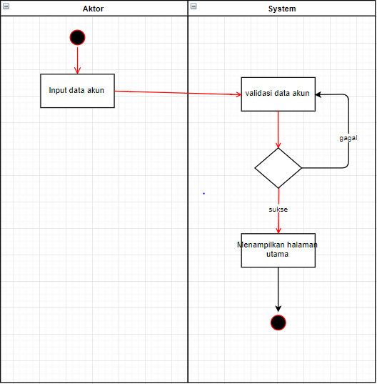

1. Activity Diagram Create Akun

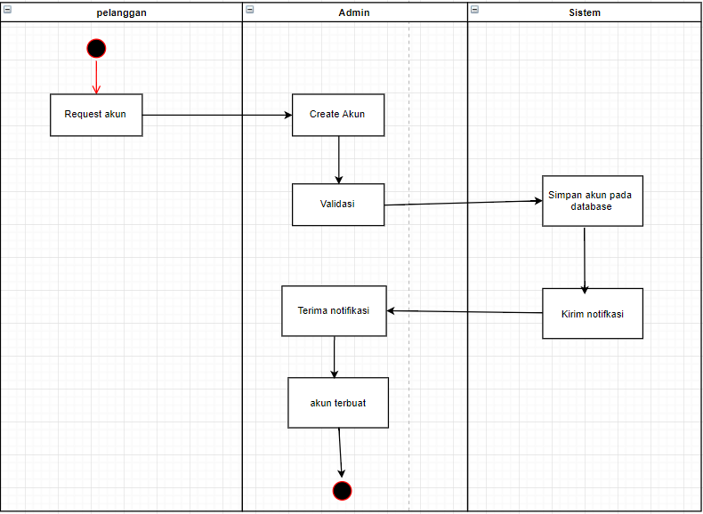

1. Activity Diagram Update Akun

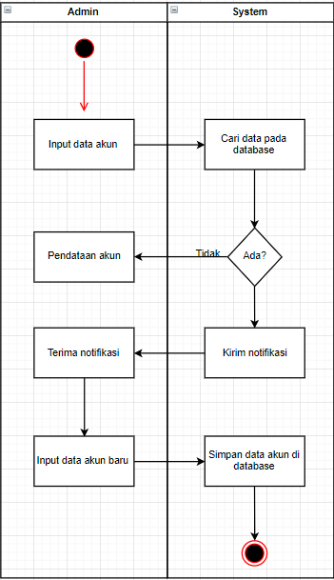

1. Activity Diagram View Akun

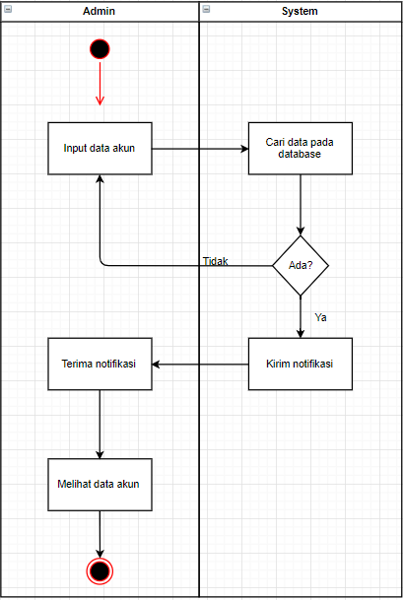

1. Activity Diagram Delete Akun

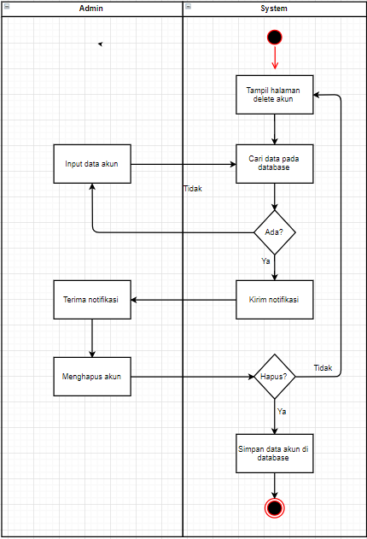

1. Activity Diagram Pendataan Resep

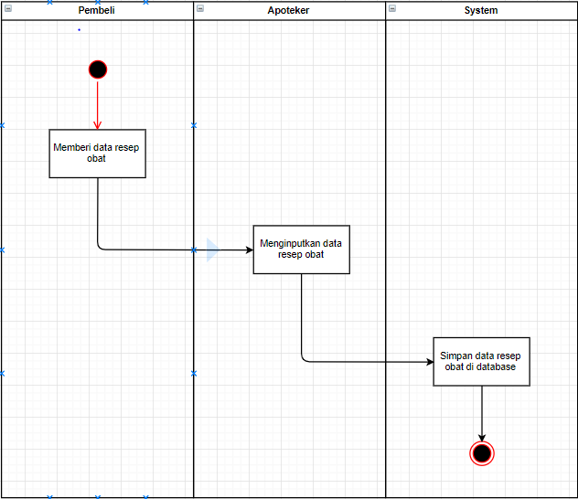

1. Activity Diagram Pendataan Racikan

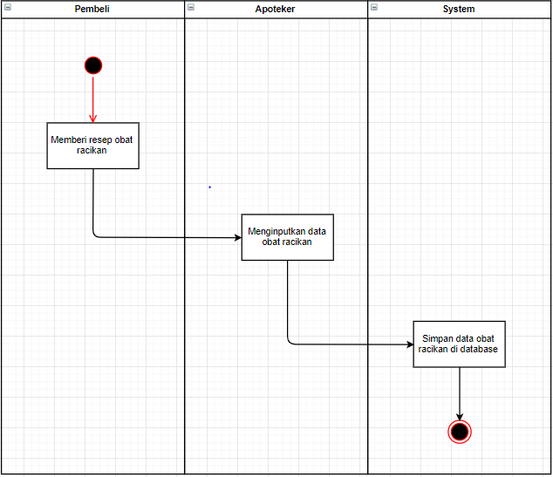

1. Acitivity Diagram Pembuatan Obat

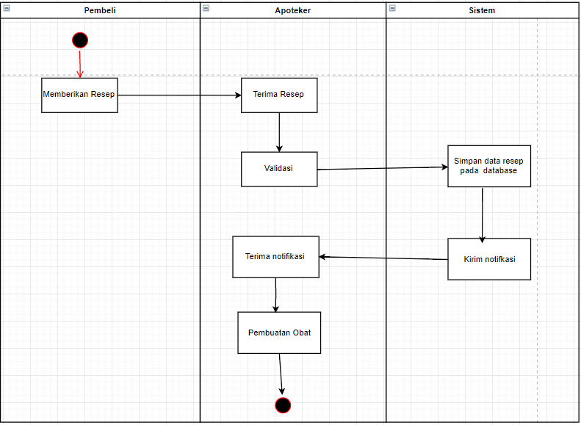

1. Activity Diagram Cek Jumlah Obat

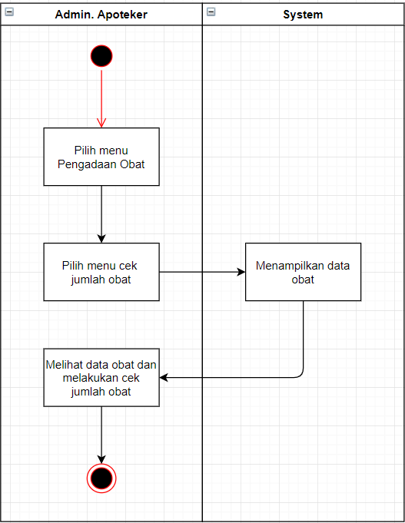

1. Activity Diagram Update Obat

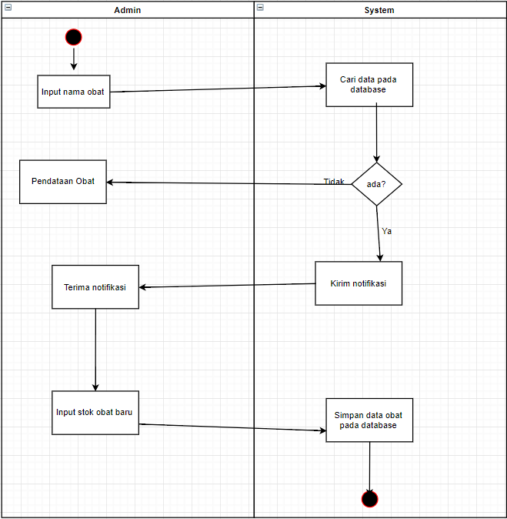

1. Activity Diagram Add Obat

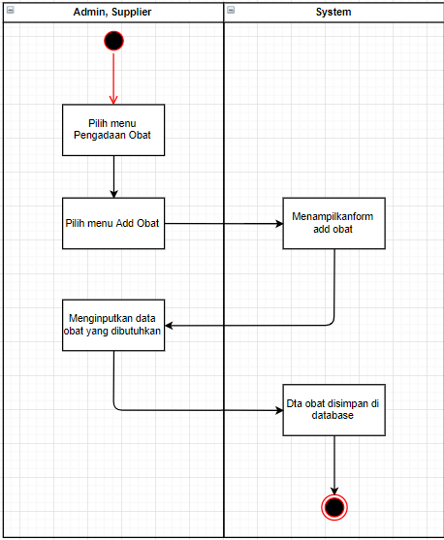

1. Activity Diagram Delete Obat

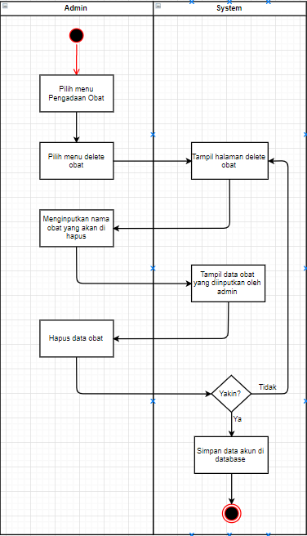

1. Activity Diagram Penerimaan Obat

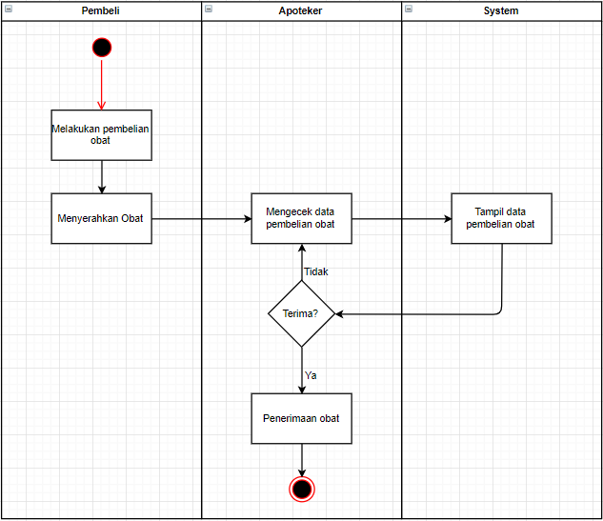

1. Activity Diagram Pemberian Obat Baru

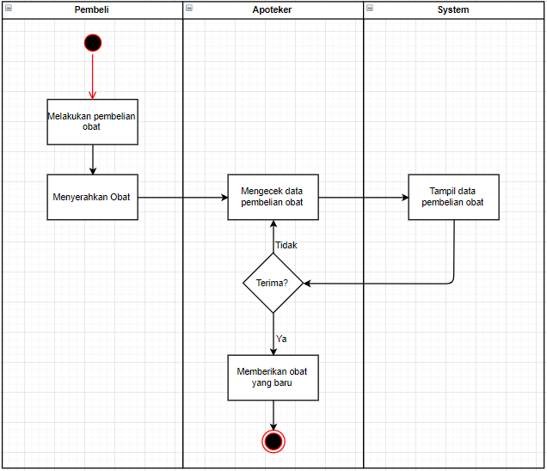

1. Activity Diagram Transaksi Pembelian Obat

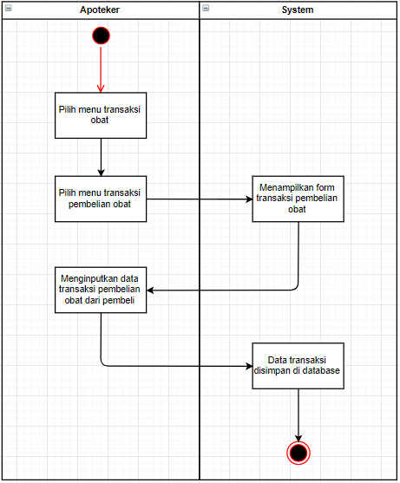

1. Activity Diagram Transaksi Pembelian Bahan

